**EXP 13** Create a Virtual Hard Disk and allocate the storage using VM ware Workstation

**PROCEDURE:**

**STEP 1 I**nstall VM ware software

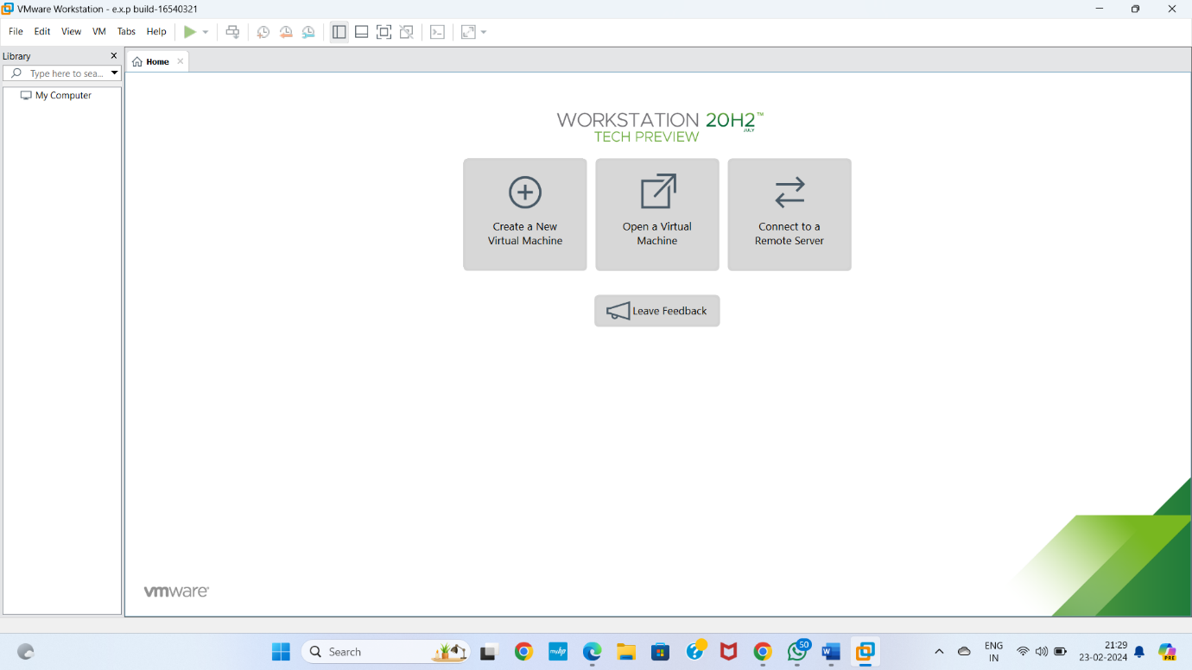

**Step 2** CREAT A NEW VIRTUAL MACHINE GIVE NEXT

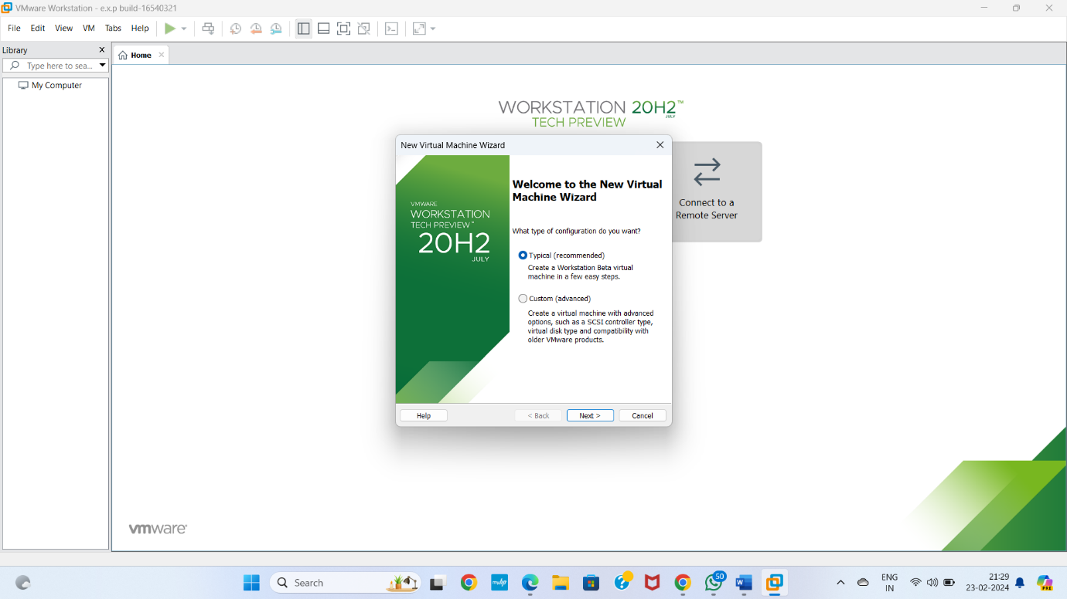

**STEP 3** Select I will install operating system later Give next

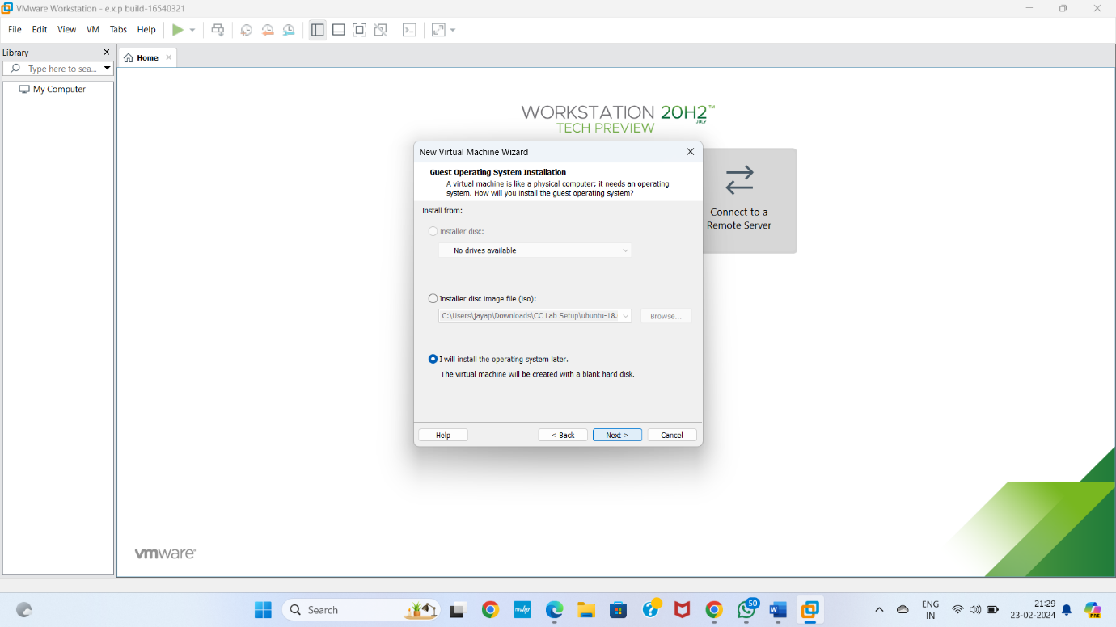

**STEP 4** Select gust operating system Give next

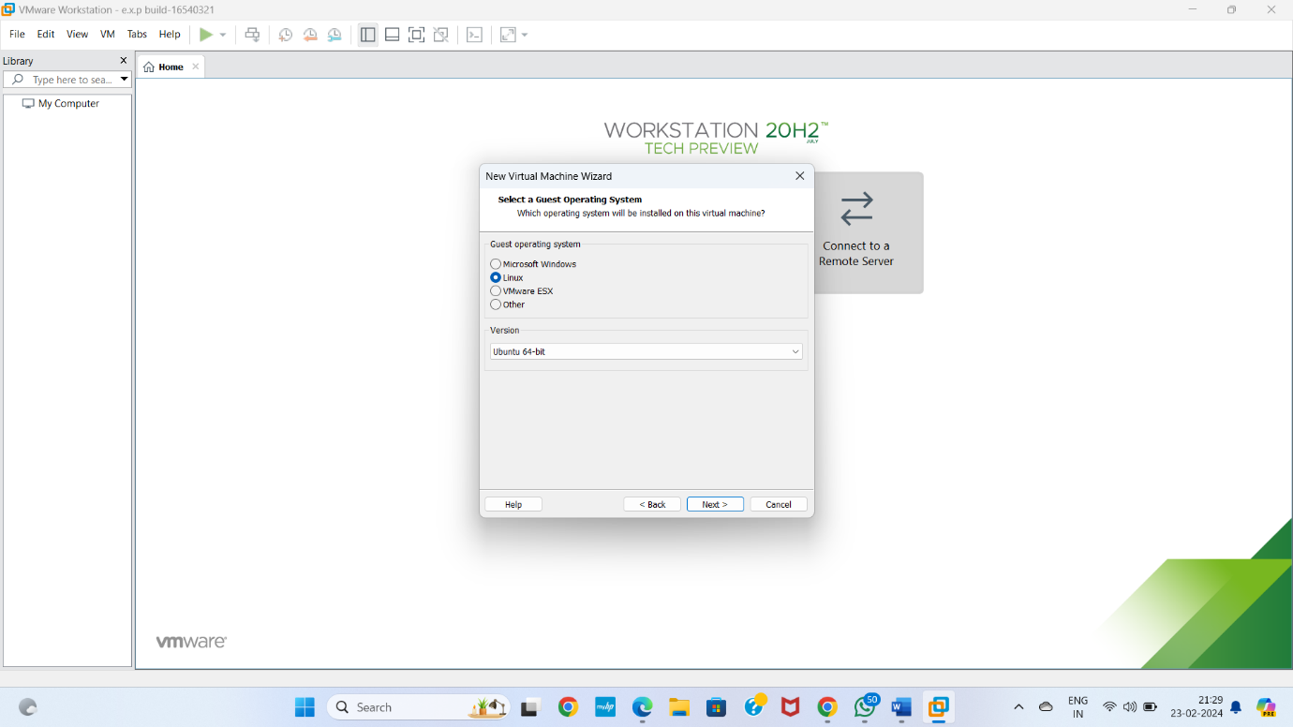

**STEP 5** selects name of virtual machine Give next

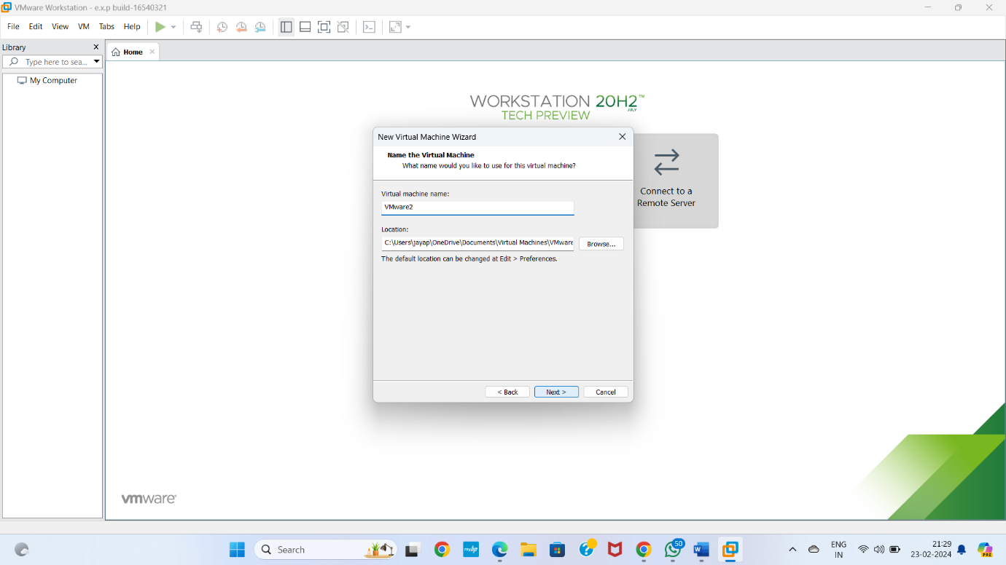

**STEP 6** Select the data storing disk and maximum size of disk Give next

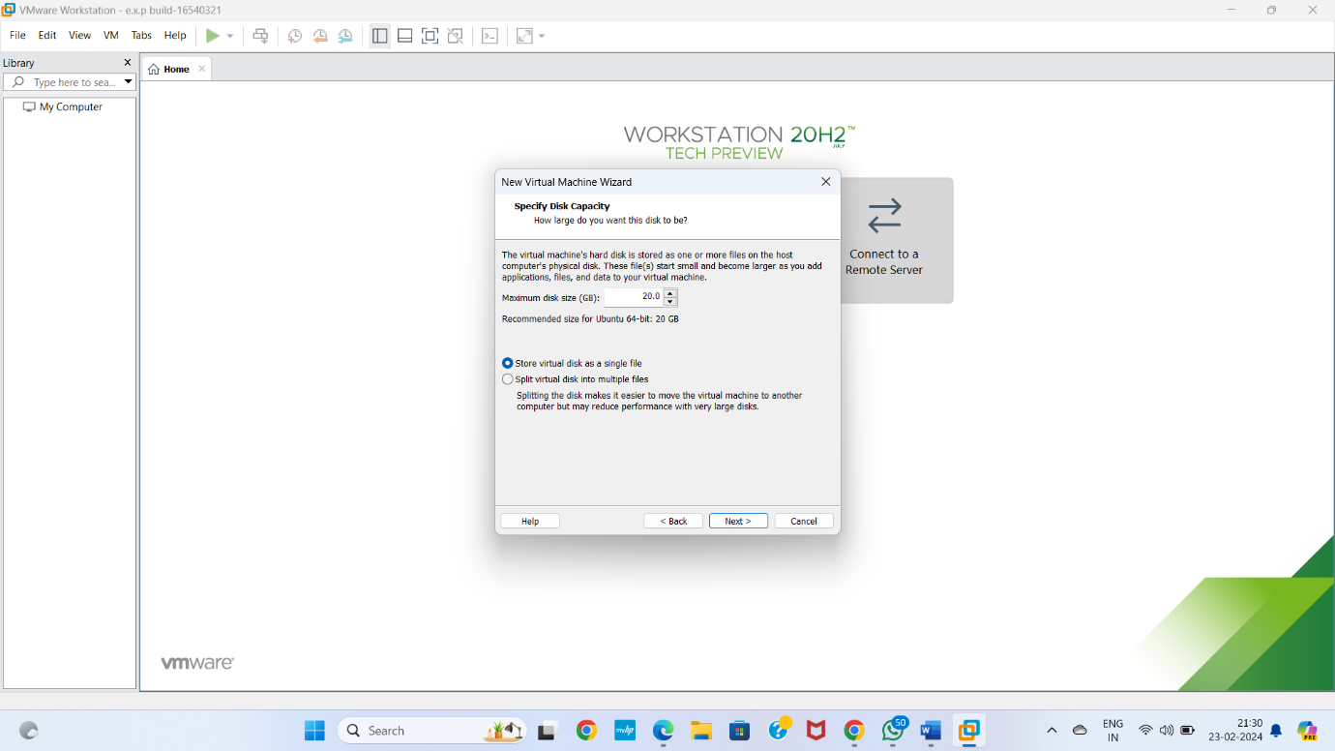

**STEP 7** Ready to create virtual machine Give finish

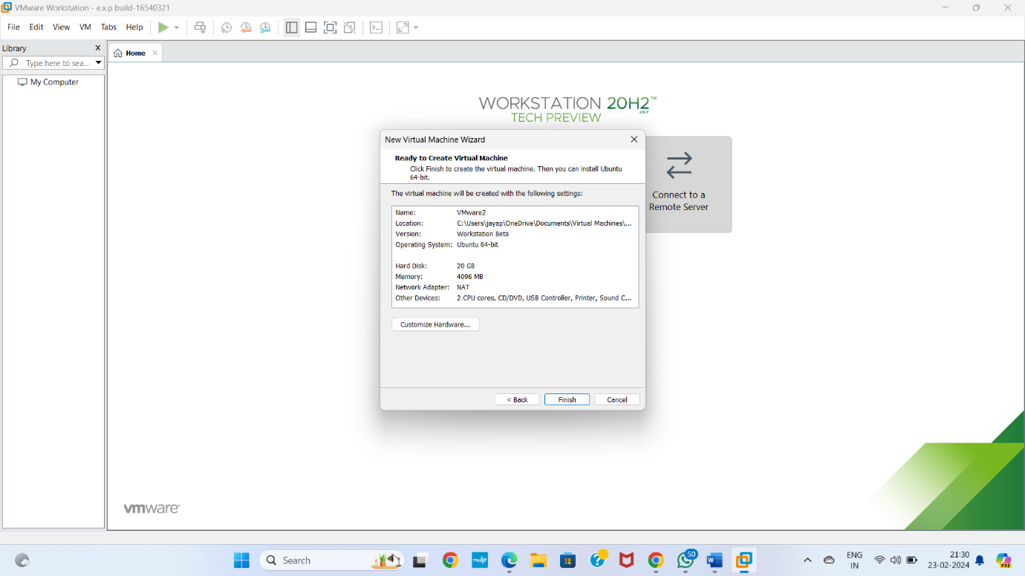

**STEP 8** Created the virtual machine

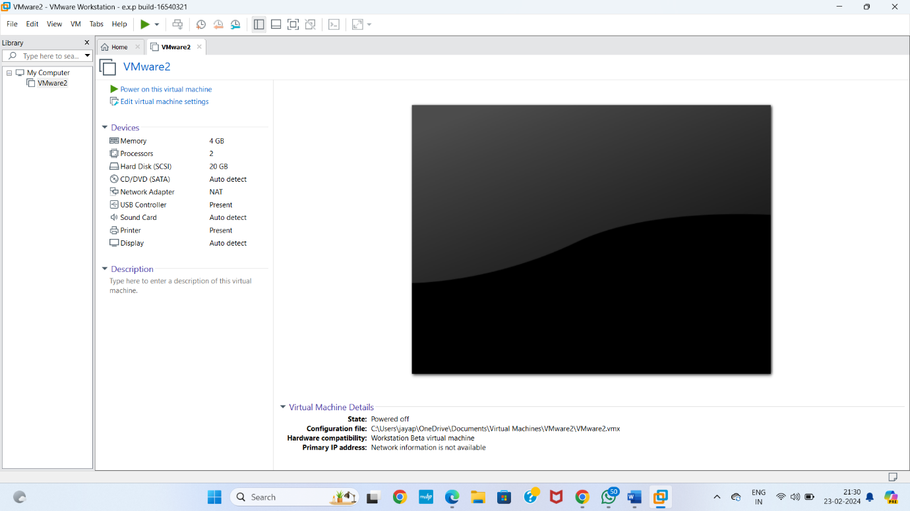

**STEP 9** Create a Virtual Hard Disk and allocate the storage using VM ware Workstation

Goto edits virtual machine

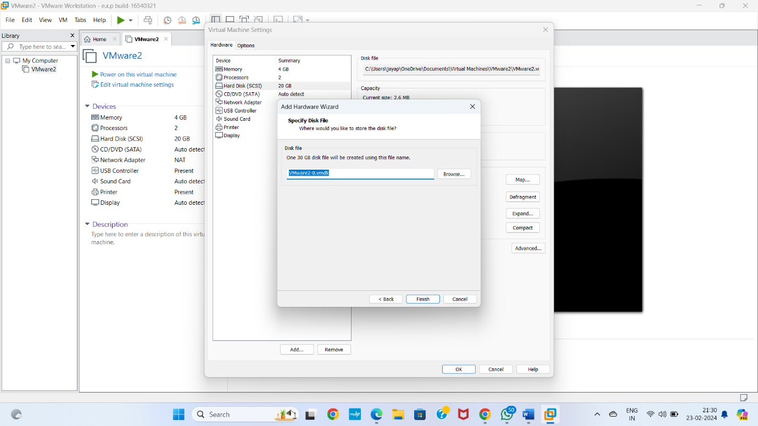

**STEP 10** Virtual hard disk ready Give ok

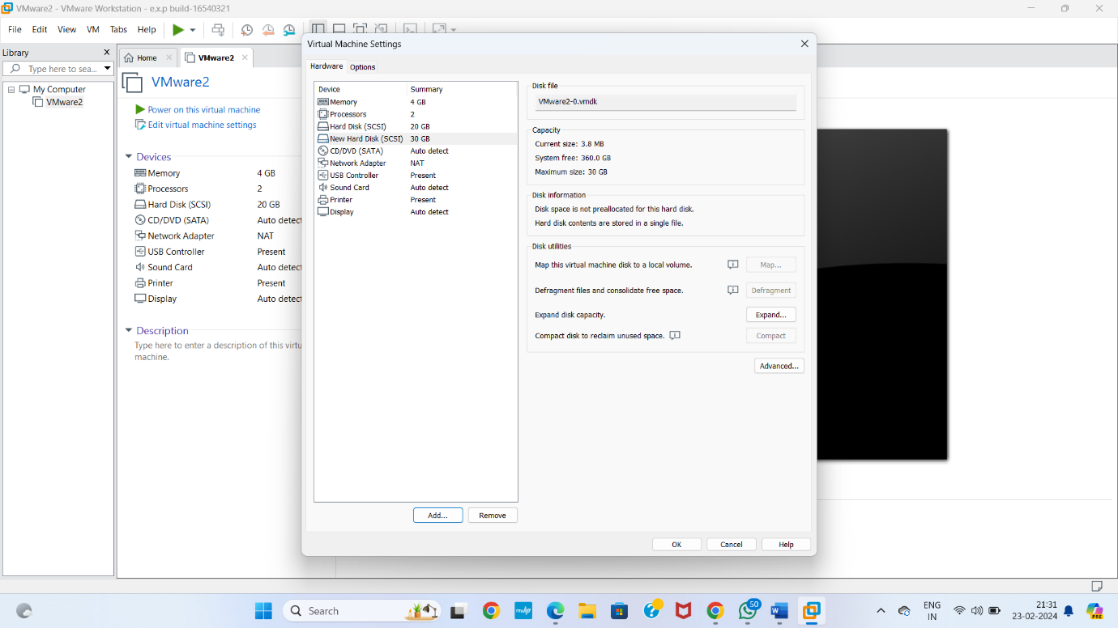

**STEP 11** Virtual machine is created by new hard disk

